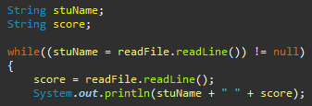

Since this program was building off of the first program a huge portion was pretty easy to finish as I had already written most of the code down. This doesn't mean I didn't have problems as I did encounter a few. The main problem I had was I just didn't make a StuName program which is why I couldn't get the program to run. I guess I forgot to make it which ultimately led to the program not working at all. Once I realized that I had to make one I was able to make a new Java program and finish the whole task. I had some difficulties with the StuName class as well which Nolan was able to come over and help me complete it.

**Wrong**



**Correct**

